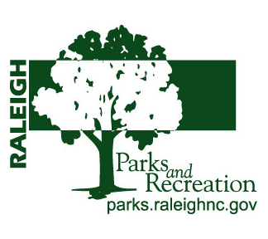City of Raleigh Parks and Recreation Volunteer Application
(Volunteers 18 years & younger must have a parent’s signature. Volunteers must also complete the attached background investigation and Park or Program Release & Indemnity Form.) Please print or type.

Name: ____________________________________________________________________________________
Last First Middle Initial

Address: __________________________________________________________________________________

City: _______________________________________________________State: ________ Zip: _____________

Phone (home): ______________________________ (cell):_____________________________________

Email: ___________________________________________ Birthdate: ______________________

Agency or Group (if applicable): _______________________________________________________________

Special talents or skills: ______________________________________________________________________

What type of schedule would work for you: ______________________________________________________

In case of emergency, notify:__________________________________________________________________

Relationship:_________________________________ Phone: ______________________________

Number of Hours Assigned (if applicable): _______________ Deadline for completion: _________________

Please sign below when you have read and understand all statements.
I certify that the statements made in this Volunteer Application are true, correct, and given voluntarily. In addition,
I understand that this information may be disclosed to any party with legal and proper interest.

I understand that the Raleigh Parks and Recreation Department reserves the right to screen volunteers, and the Department will not accept as a volunteer anyone who would jeopardize any aspect of service or the safety of Parks and Recreation customers and staff.

I understand that if I am unable to show up for a scheduled time for any reason, I am to notify my supervisor as soon as possible.

I understand that if I miss my scheduled date and time of service without prior notification, my volunteer opportunity may be terminated by the affected park site/ program supervisor.

I understand that I will not be paid for my services as a volunteer, and I am giving my time freely to the department/division to which I am assigned.

I will also not abuse any information, materials, or hardware I may use or obtain while volunteering.

Applicant Signature: _______________________________________________________ Date: __________

Parents/Guardian’s Signature: _______________________________________________ Date: __________
(If applicant is under 18)
Parks and Recreation Site/ Program Supervisor Signature ____________________________ Date: __________

Non-Discrimination Policy – The City of Raleigh Parks and Recreation Department does not discriminate on the basis of race, color, national origin, sex, religion, age, sexual orientation or disability in employment opportunities or the provision of services, programs or activities. A participant alleging discrimination on the basis of any of the areas may file a complaint with either the Director of the Raleigh Parks and Recreation or the Office of Equal Opportunity, U.S. Department of the Interior, Washington, DC 20240

